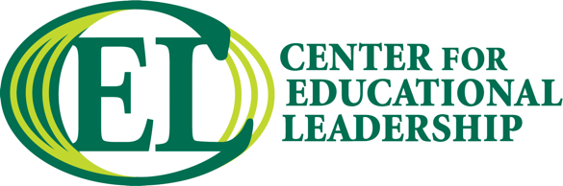

Ohio Education Policy Fellowship Program
2024-2025

Program Application Guidelines

- Please submit your application with the following materials to the Center for Educational Leadership:
- Fully completed application.
- Recommendation Letter from your supervisor or employing agency representative
- Resume
- Brief (150-250 word) Biography that will be shared with CSU staff, facilitators and other Fellows
- Photo (headshot), jpeg format

- You can submit your application materials by email to center_edleadership@csuohio.

- Notification of acceptance into the program will be emailed.

Education Policy Fellowship Program
2024-2025 PROGRAM APPLICATION

Applicant Profile
First Name:
Last Name:
Professional Title:
Number of years in current position:
Institution/Organization:
Institution/Organization
Address:
City: |  |  |  |  | State: |  | Zip Code:
Business Phone: |  |  |  |  |  | Business Fax:
*Personal Email Address: |  |  | ◻ Primary Email
*Business Email Address: |  |  | ◻ Primary Email
Home Address:
City: |  |  |  |  | State: |  | Zip Code:
Home Phone: |  |  |  |  |  | Cell Phone:

As a matter of policy, Cleveland State University does not discriminate among applicants of participants on the basis of race, religion, gender, national origin, or handicap. Supplying the following information is optional.
◻ | African American | ◻ | Female
◻ | Asian American | ◻ | Male
◻ | Caucasian
◻ | Latino/a
◻ | Native American
◻ | Other

Please answer the following questions regarding your academic experience.
Education (Please list most recent first.)
Graduate:
College or University
Degree
Field or Major
Year Completed
College or University
Degree
Field or Major
Year Completed
Undergraduate:
College or University
Degree
Field or Major
Year Completed

Is there anything else you would like to tell us about your academic background?

◻ | Please check if you are interested in receiving graduate credits for this program.

Interest Survey

1. What do you hope to gain from your participation this program?

2. What contemporary education policy issue or issues are you most interested in?

3. What contemporary education policy issue or issues would you like to learn more about?

4. How would you describe your current level of involvement with and understanding of education policy?

Endorsement
To the Supervisor or Employing Agency Representative (Sponsor):

The Ohio Education Policy Fellows will be expected to attend monthly virtual sessions and five out-of-town and/or overnight trips.

Your signature below ensures the employee applicant’s release time for full participation in the Fellowship Program. Your signature below also ensures your commitment to underwrite some or all of the expenses associated with the program (a $3,500 program fee payable to Cleveland State University).

To be completed by the Applicant’s Supervisor (Sponsor) to approve release time and/or program expenses:

Print name: _______________________________________ __

Title: _____________________________________ ____

Organization: ____________________________ ____________

Street: _______________________________________________________________

City: ________________________________ State: ________ Zip:_______________

Email Address: ________________________________________________________

Phone Number: ________________________________________________________

_____________________ ___ __________ __

Signature Date

Please indicate if you are not committing to underwrite expenses here: __________________

Applicant Commitment

Your signature below ensures that, if accepted into the Education Policy Fellowship Program, you have made a commitment to attend all of the sessions planned for the 2024-2025 year, complete the policy project, and assume any program expenses not agreed to be borne by your employing agency or sponsor.

Applicant’s Signature Today’s date

